Title: Lab 5 – Clean Cuts: Classic Binary Search Trees with Full Traversals
Author: Javier Tellez, Jeremias Serrat
Date: 10/23/2025
Course: COP 3530 – 86511, DS&A.

Problem Statement:
The purpose of this lab was to work as a team to develop a program to apply our abilities in object-oriented programming and our knowledge in Binary Search Trees. The composition of the program was to receive a certain number of integers and have the system sort them into a Binary Search Tree. The system had to follow the conditions of the Binary Search Tree, exclude duplicate values, and print out the three learned traversal algorithms: in-order, pre-order, and post-order.
Concepts & Tools Used:
- Binary Search Trees
- Recursive traversal algorithms
- Header Files
- Object Oriented Programming
- Manual Memory Allocation

Description of Logic:
The program revolves around the construction, traversal, and management of a Binary Search Tree data structure. The program uses object-oriented programming principles to create modular, reusable, and well-organized code. The Binary Search Tree is made up of nodes, where each node holds: A key, a left child, and right child pointers.
Step 1:
The program begins by asking the user how many numbers they want to insert into the binary tree and the list of integer values to store. These values are stored in an array, then inserted one by one into the Binary Search Tree using the InsertKey() function. To ensure that each element is placed in the correct position according to Binary Search Tree rules.
Step 2:
The construction of the tree happens through the InsertKey() and InsertNode() functions:
- InsertKey(int key) checks if the key already exists using the Contains() function. If it does not exist, it creates a new node and passes it to InsertNode().
- InsertNode(BSTNode* newNode) Handles the actual placement of the new node in the correct location:
  - If the tree is empty, the first node becomes the root.
  - Otherwise, the program iteratively traverses the tree starting from the root:
    - If the new key is less than the current node key, move to the left child.
    - If it is greater than the current node key, move to the right child.
- Once an empty spot is found, the new node is linked to that position.
Step 3:
The Search(int searchkey) function is used to locate a value within the tree:
- It starts from the root and compares the search key with each node’s key.
- If the key matches, it returns a pointer to that node.
- If the key is smaller, it continues to the left; if larger, it moves to the right.
- The process repeats until the key is found, or the tree ends.
This makes searching efficient, with an average time complexity of O(log n) for balanced trees.
Step 4:
Once the tree is built, the program displays the elements using tgree traversal methods.
Each traversal uses a recursive function that automatically visits nodes in a specific order.
- In-order traversal (Left > Root > Right)
- Pre-order traversal (Root > Left > Right)
- Post-order traversal (Left > Right > Root)
Each traversal is implemented through a recursive helper function that receives a node pointer and continues calling itself until reaching a leaf node.
Step 5:
When the program ends, the destructor (~BinarySearchTree) automatically calls the DeleteTree() function, which recursively:
- visits all nodes starting from the root
- deletes each node after its children are deleted
- and frees all dynamically allocated memory to prevent leaks.
Step 6:
Finally, the program prints the traversal results to the console. Each traversal is labeled clearly, and the node values are displayed in order determined by the traversal type. This gives the user a complete visualization of how the tree structure organizes data differently under each traversal pattern.

Sample Code
Clean_Cuts_2015.cpp
Source file
#include <iostream>
#include "BST.h"
BSTNode::BSTNode(int nodeKey, BSTNode* leftChild, BSTNode* rightChild) { //Basic constructor
key = nodeKey;
left = leftChild;
right = rightChild;
}
//Functions for in, pre, and post-order traversal
void BinarySearchTree::BSTInOrder(BSTNode* node) {
if (node) {
BSTInOrder(node->left); //First print/travel to left node subtree
std::cout << "Value: " << node->key << std::endl; //Print key of current subtree root node
BSTInOrder(node->right); //Last, print/travel to right node subtree
//Function will recursively go through each node under the node specificed in the argument, and
//print the keys in the order: left->root->right
}
}
void BinarySearchTree::BSTPreOrder(BSTNode* node) {
if (node) {
std::cout << "Value: " << node->key << std::endl; //First print key of current subtree root node
BSTPreOrder(node->left); //Then print/travel to left node subtree
BSTPreOrder(node->right); //Last, print/travel to right node subtree
//Function will recursively go through each node under the node specificed in the argument, and
//print the keys in the order: root->left->right
}
}
void BinarySearchTree::BSTPostOrder(BSTNode* node) {
if (node) {
BSTPostOrder(node->left); //First print/travel to left node subtree
BSTPostOrder(node->right); //Then print/travel to right node subtree
std::cout << "Value: " << node->key << std::endl; //Last, print key of current subtree root node
//Function will recursively go through each node under the node specificed in the argument, and
//print the keys in the order: root->left->right
}
}
//Functions for printing in, pre, and post-order traversal types from the root
void BinarySearchTree::BSTPrintInOrder() {
std::cout << "Traversal Type: In-Order" << std::endl;
BSTInOrder(root); //Call in-order traversal function from root to print the whole tree
}
void BinarySearchTree::BSTPrintPreOrder() {
std::cout << "Traversal Type: Pre-Order" << std::endl;
BSTPreOrder(root); //Call pre-order traversal function from root to print the whole tree
}
void BinarySearchTree::BSTPrintPostOrder() {
std::cout << "Traversal Type: Post-Order" << std::endl;
BSTPostOrder(root); //Call post-order traversal function from root to print the whole tree
}
//BST class function implementations
//Recursive function that goes through a subtree's nodes and deletes all of them
void BinarySearchTree::DeleteTree(BSTNode* subtreeRoot) {
if (subtreeRoot) { //If null, break (goes back to previous recursive function call)
DeleteTree(subtreeRoot->left);
DeleteTree(subtreeRoot->right);
delete subtreeRoot;
}
}
//Function to search for a given node starting from the tree's root
BSTNode* BinarySearchTree::Search(int searchKey) {
BSTNode* currentNode = root;
while (currentNode) { //Loop breaks when currentnode becomes null; search key was not found
if (searchKey == currentNode->key) {
return currentNode; //Return currentnode if searchkey was found at currentnode
}
else if (searchKey < currentNode->key) {
currentNode = currentNode->left; //Move to left child if searchkey is less than the currentkey
}
else {
currentNode = currentNode->right; //Move to right child if searchkey is greater than currentkey
}
}
return nullptr;
}
//Insert node according to proper BST order
void BinarySearchTree::InsertNode(BSTNode* newNode) {
if (root == nullptr) {
root = newNode; //Set newnode as the tree's root if the BST is empty
}
else { //If the BST is not empty (has at least 1 existing node)
BSTNode* currentNode = root; //Set currentnode to the root to start from the BST's root
while (currentNode) {
if (newNode->key < currentNode->key) { //If the newnode's key is less than the currentnode...
if (currentNode->left == nullptr) { //Set the newnode to the left child of the current node if it's empty
currentNode->left = newNode;
currentNode = nullptr; //Set currentnode to null to break the loop (since the newnode has been placed)
}
else {
currentNode = currentNode->left; //Otherwise, if the left child is occupied, move to the left
}
}
else { //If the newnode's key is greater than the currentnode...
if (currentNode->right == nullptr) { //Set the newnode to the right child of the current node if it's empty
currentNode->right = newNode;
currentNode = nullptr; //Set currentnode to null to break the loop (since the newnode has been placed)
}
else {
currentNode = currentNode->right; //Otherwise, if the right child is occupied, move to the right
}
}
}
}
}
//Function to see if a key already exists in the BST
bool BinarySearchTree::Contains(int key) {
return Search(key) != nullptr; //Returns true if the argument key already exists in the tree
}
//Function to insert a new key into the BST
bool BinarySearchTree::InsertKey(int key) {
if (Contains(key)) { //Ignore/disallow duplicate keys
return false;
}
InsertNode(new BSTNode(key)); //If there are no duplicates, call to insert the new key
return true;
}
//Constructor and Destructor for BST class
BinarySearchTree::BinarySearchTree() {
root = nullptr; //Set root to null for an empty BST
}
BinarySearchTree::~BinarySearchTree() {
DeleteTree(root); //Delete the entire tree (call delete function starting from tree root)
}

Header code
#ifndef BST_H
#define BST_H
//Class for the nodes used in the BST implementation
class BSTNode {
public:
int key;
BSTNode* left; //Pointer to left child node
BSTNode* right; //Pointer to right child node
//Default class constructor declaration to initialize variables
BSTNode(int nodeKey, BSTNode* leftChild = nullptr, BSTNode* rightChild = nullptr);
};
class BinarySearchTree {
private:
BSTNode* root; //Declare root node to be used as start/root of BST
//Recursive function that goes through a subtree and deletes all nodes under it
void DeleteTree(BSTNode* subtreeRoot);
//Recursive functions that travel through the BST according to the traversal type
void BSTInOrder(BSTNode* node);
void BSTPreOrder(BSTNode* node);
void BSTPostOrder(BSTNode* node);
public:
//Functions that print the results of the other traversal functions
void BSTPrintInOrder();
void BSTPrintPreOrder();
void BSTPrintPostOrder();
//Function declaration for searching for a key
BSTNode* Search(int searchKey);
//Functions responsible for inserting new nodes and checking for duplicates
void InsertNode(BSTNode* newNode);
bool Contains(int key);
bool InsertKey(int key);
//Constructor and Destructor declarations
BinarySearchTree();
~BinarySearchTree();
};
//This needs to be below every class and class function for the implementation
//file to recognize
#endif //BST_H

Main code
#include <iostream>
#include "BST.h"
int main() {
//Create an object of the BST class
BinarySearchTree tree;
int n; //Variable for number of tree values
std::cout << "Enter the number of values you want to enter into a BST:" << std::endl;
std::cin >> n;
int array[n]; //Create an array of specified size to hold the elements that are to enter the BST
std::cout << "Enter the elements of the tree:" << std::endl;
//Loop to take user input for BST elements/keys
for (int i = 0; i < n; i++) {
std::cin >> array[i];
}
//Insert input values into the tree
for (int i = 0; i < n; i++) {
tree.InsertKey(array[i]);
}
//Print in, pre, and post-order traversals of the input BST
tree.BSTPrintInOrder();
tree.BSTPrintPreOrder();
tree.BSTPrintPostOrder();
return 0;
}

Sample Output:
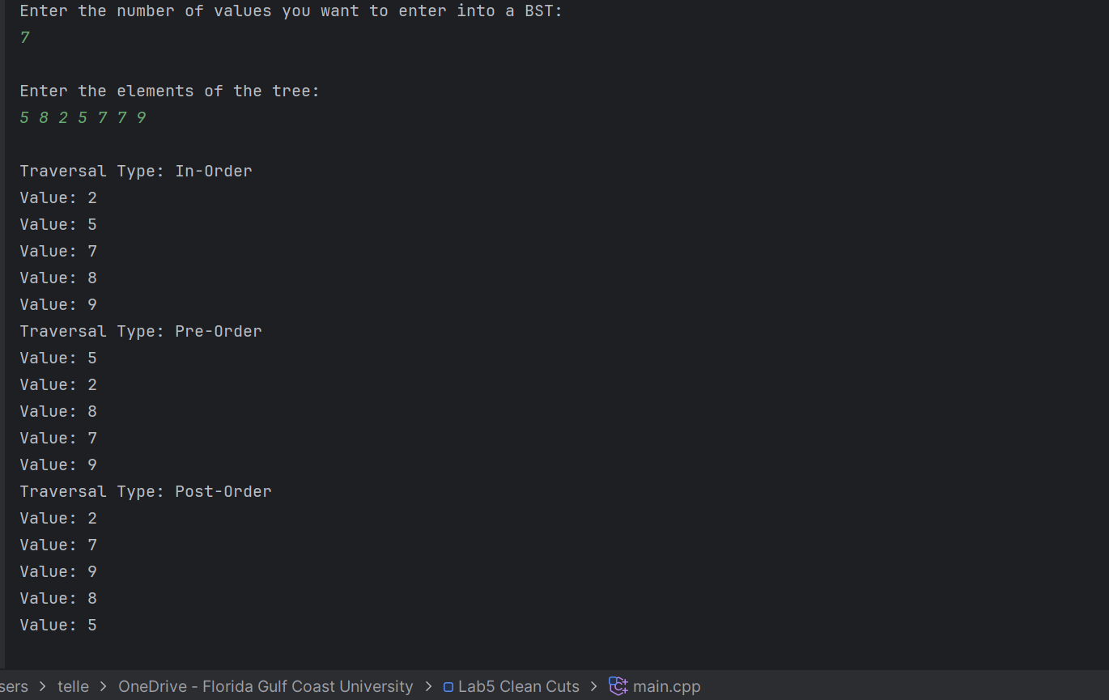

Reflection
The project helped us gain an ability on how our future career will be. Teamwork and knowing how to use our knowledge to collaborate on one project is essential as further on we are tasked to work with various programmers who have different ways of working and experience we can learn from. This collaboration gave us a bigger idea on how binary search trees work, for when we are preparing for our technical interviews. How the system can traverse through the binary search tree in different orders, in-order, post-order, and pre-order, that will be important depending on the need of the employer for its system. It reinforced our ability in object-oriented programming, given that header files have been a topic we haven’t touched on since a couple of semesters ago, so it was helpful to practice it once more. This was a complete project to learn the implementation of binary search tree, as it integrates topics we have learned from this course and previous courses.

References

- Olds, E. & Lysecky R. (2024). Data Structures in C++. zyBooks, a Wiley brand. https://www.zybooks.com/catalog/data-structures-c-plus-plus/ (accessed 2025).
- Vahid, F. & Lysecky R. (2025). Programming in C++. zyBooks, a Wiley brand. https://www.zybooks.com/catalog/programming-c-plus-plus/ (accessed 2025).

